Topic 1: Working as a Physicist

0.1 Specification notice:
Throughout their study of physics at this level, students should develop their knowledge and understanding of what it means to work scientifically. They should also develop their competence in manipulating quantities and their units, including making estimates.
Students should gain experience of a wide variety of practical work that gives them opportunities to develop their practical and investigative skills by planning, carrying out and evaluating experiments. Through studying a range of examples, contexts and applications of physics, students should become increasingly knowledgeable of the ways in which the scientific community and society as a whole use scientific ideas and methods, and how the professional scientific community functions.
Students should develop their ability to communicate their knowledge and understanding of physics in ways that are appropriate to the content and to the audience.

It is not intended that this part of the specification be taught as a discrete topic. Rather, the knowledge and skills specified here should pervade the entire course and should be taught using examples and applications from the rest of the specification.

1.Q Exam questions

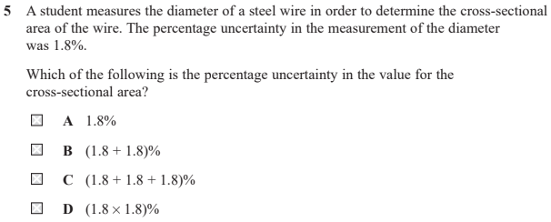  Which of the following is the %U in the value for the cross-sectional area? | 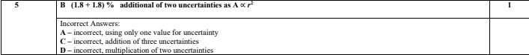  - B is answer
What are common criticisms for ‘criticising the students results questions’? | - Number of decimal places for RAW DATA  - Number of significant figures for Processed/calculated DATA  - Range is too small for values  - No evidence of repeats  - Not enough readings e.g between 24 and 60 degrees celsius  - E.g Four pairs of readings are not enough (for qu below)  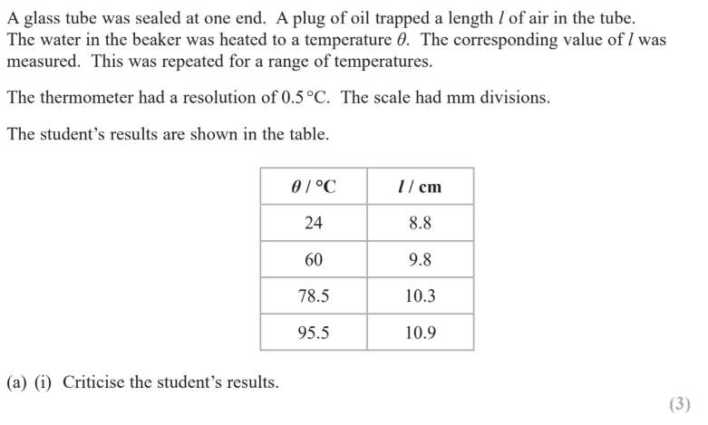
How would using a data logger make an experiment more accurate compared to taking measurements manually? | - Dataloggers are useful when data changes over a very short (or very long) time scale  - Dataloggers are useful when a number of quantities are being measured simultaneously  - Dataloggers remove human reaction time  - Dataloggers have a high sampling rate  You may also need to mention data loggers with lightgates
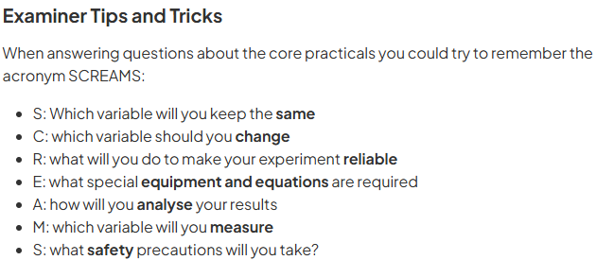

1.1 - Know and understand the distinction between base and derived quantities and their SI units
What is an Si base quantity, Si base unit and derived quantity, derived unit
What is the SI unit and symbol for Mass? | Kilogram, kg
What is the SI unit and symbol for Time? | Second,s
What is the SI unit and symbol for Temperature? | Kelvin, K
What is the SI unit and symbol for Current? | Ampere, A
What is the SI unit and symbol for Amount of substance? | Mole, mol
What is the SI unit and symbol for Length? | Metre,m
What is the SI unit and symbol for Luminous intensity? | Candela. cd
What is the SI base quantity and symbol for Kilogram? | Mass, m
What is the SI base quantity and symbol for a Second? | Time, t
What is the SI base quantity and symbol for Kelvin? | Temperature, T
What is the SI base quantity and symbol for Ampere? | Electric current, I (or i)
What is the SI base quantity and symbol for Mole? | Amount of substance, n
What is the SI base quantity and symbol for Metre? | Length, l
What is the SI base quantity and symbol for Candela? | Luminous intensity, I
What are the prefixes for 1000? | Kilo K - 10³
What are the prefixes for 1,000,000? | Mega M - 10⁶
What are the prefixes for 1,000,000,000? | Giga G - 10⁹
What are the prefixes for 1,000,000,000,000? | Tera T - 10¹²
What are the prefixes for 0.001? | Milli m - 10⁻³
What are the prefixes for 0.000,001? | Micro μ - 10⁻⁶
What are the prefixes for 0.000,000,001? | Nano n - 10⁻⁹
What are the prefixes for 0.000,000,000,001? | Pico p - 10⁻¹²
What are the prefixes for 0.000,000,000,000,001? | Femto f - 10⁻¹⁵
What is the derived unit of Newton (Force)? | kgms⁻²
What is the derived unit of Joule (Energy/Work done)? | kgm²s⁻²
What is the derived unit of Watt (Power)? | kgm²s⁻³
What is the derived unit of Hertz (Frequency)? | s⁻¹
What is the derived unit of Coulomb (Charge)? | As
What is the derived unit of Volt (Voltage)? | kgm²s⁻³A⁻¹
What is the derived unit of Ohm (Resistance)? | kgm²s⁻³A⁻²

1.2 - Be able to demonstrate their knowledge of practical skills and techniques for both familiar and unfamiliar experiments
What is a ‘rough’ rule for which instrument you should use to measure the length of something? | - Length is 1cm or greater use a ruler (or measuring tape)  - Length is between 10mm and a few cm vernier caliper  - Length is between 0.01mm - 10mm use a micrometer or digital caliper  Digital vernier caliper is not allowed for digital caliper as they are different

1.3 - Be able to estimate values for physical quantities and use their estimate to solve problems

1.4 - Understand the limitations of physical measurement and apply these limitations to practical situations
What is a random error? | A statistical fluctuation in data due to the experimenters ability
What is a systematic error? | Inaccuracies that are present throughout the whole experiment
How would you reduce the chance of a random error? | Repeating measurements and calculating an average
How would you reduce the chance of a systematic error? | By recalibrating instruments
What does a random error affect and the result of it? | The precision of measurements taken causing a wider spread of results about the mean value
What does a systematic error affect and the result of it? | The accuracy of all readings obtained
What is a zero error? | A type of systematic error that occurs when an instrument gives a reading when in fact the true reading is zero
What should you do if there is a zero error? | Recalibrate the device
Define precision? (1) | Is the consistency of values obtained by repeated measurements (1)
Define accuracy? (1) | How close the measured value is to the true value (1)
What is the resolution? | The smallest division on a measuring instrument
What is the equation for absolute uncertainty? | 0.5 x smallest division (depends on the situation)
What is the equation for percentage uncertainty? | Percentage uncertainty = absolute uncertainty/value x 100
What is the equation for fractional uncertainty? | Fractional uncertainty = absolute uncertainty/value
How would you find the uncertainty from a reading? | Half the smallest division
How would you find the uncertainty from a digital reading? | The resolution of the equipment unless otherwise quoted
How would you find the uncertainty from a measurement? | At least +-1 smallest division
How would you find the uncertainty from repeated data? | Half of the range of values given to the same no of d.p
How would you find the uncertainty from data? | The lowest number of significant figures
What are readings and measurements and the absolute uncertainty of both? And to what decimal place should they be? | Readings  Absolute uncertainty is ½ resolution  No zero error because you’re not lining things up (e.g., thermometers. Measuring cylinders)  - Measurements  Absolute uncertainty is the resolution  Zero error because you’re lining up with zero (e.g., ruler, stopwatch, micrometre, vernier callipers)  - They should be to no greater no. of decimal places than the value it is for  E.g if you calculate the uncertainty for 0.29mm to be 0.0081mm then it must be 0.01mm
What are readings and the absolute uncertainty of it? And to what decimal place should they be? | Absolute uncertainty is half the resolution. No zero error because you are not lining things up (e.g. thermometers, measuring cylinders)  It should be to no greater no. of decimal places than the value it is for
What should you do when adding or subtracting with uncertainties? | Add the ABSOLUTE UNCERTAINTIES
What should you do when multiplying or dividing with uncertainties? | Add the PERCENTAGE UNCERTAINTIES
What should you do when you have an uncertainty to a power? | Multiply the PERCENTAGE UNCERTAINTY by the power  I.e 4/3pir³ and Absolute uncertainty = 4, r= 2  (4/2 x 100) x3 = 600
What is Validity? | A measurement is valid if it measures what it is supposed to be measuring
What is a true value? | The value that would have been obtained in an idea measurement
What is repeatability? | The precision obtained when measurement results are obtained by a single operator using a single method over a short timescale
What is reproducibility? | The precision obtained when measurement results are obtained by different operators using different pieces of apparatus
What is uncertainty? (1) | The interval in which the true value is considered to lie
What is an error? (1) | The difference between the measured result and the true value (1)
What is the percentage difference equation? | 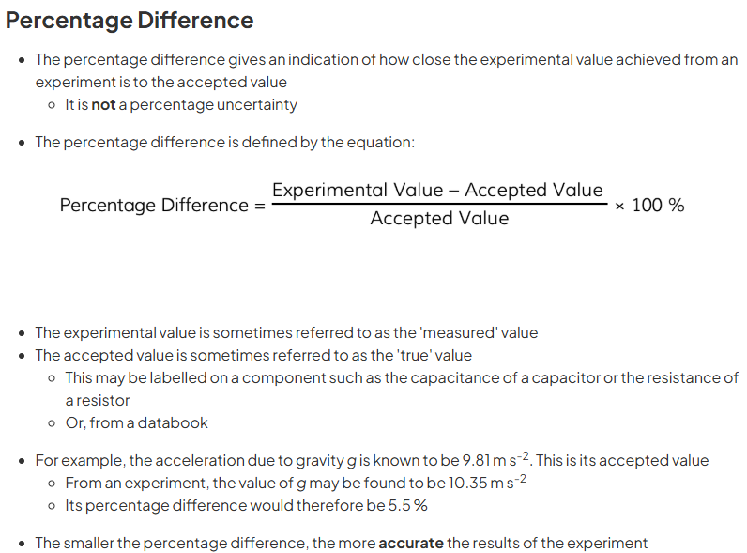  - %D = (Measured - Actual/true value) / (Actual/true value) x 100

1.5 - Be able to communicate information and ideas in appropriate ways using appropriate terminology

What is the independent variable? | What is changed
What is the dependent variable? | What is measured
What is the control variable? | What does not change

1.6 - Understand applications and implications of science and evaluate their associated benefits and risks

1.7 - Understand the role of the scientific community in validating new knowledge and ensuring integrity

1.8 - Understand the ways in which society uses science to inform decision-making

1.0 Exam command words
Command word ‘Add/label’ | Requires the addition or labelling to a stimulus material given  in the question, for example labelling a diagram or adding  units to a table.
Command word ‘Assess’ | Give careful consideration to all the factors or events that  apply and identify which are the most important or relevant.  Make a judgement on the importance of something, and  come to a conclusion where needed.
Command word ‘Calculate’ | Obtain a numerical answer, showing relevant working. If the  answer has a unit, this must be included.
Command word ‘Comment on’ | Requires the synthesis of a number of variables from  data/information to form a judgement.
Command word ‘Compare and contrast’ | Looking for the similarities and differences of two (or more)  things. Should not require the drawing of a conclusion.  Answer must relate to both (or all) things mentioned in the  question.  The answer must include at least one similarity and one  difference.
Command word ‘Complete’ | Requires the completion of a table/diagram.
Command word ‘Criticise’ | Inspect a set of data, an experimental plan or a scientific  statement and consider the elements. Look at the merits  and/or faults of the information presented and back  judgements made.
Command word ‘Deduce’ | Draw/reach conclusion(s) from the information provided.
Command word ‘Derive’ | Combine two or more equations or principles to develop a new equation.
Command word ‘Describe’ | To give an account of something. Statements in the response  need to be developed as they are often linked but do not  need to include a justification or reason.
Command word ‘Determine’ | The answer must have an element which is quantitative from  the stimulus provided, or must show how the answer can be  reached quantitatively.
Command word ‘Devise’ | Plan or invent a procedure from existing principles/ideas
Command word ‘Discuss’ | - Identify the issue/situation/problem/argument that is being assessed within the question.  - Explore all aspects of an issue/situation/problem/argument.  - Investigate the issue/situation etc by reasoning or argument.
Command word ‘Draw’ | Produce a diagram either using a ruler or using freehand.
Command word ‘Evaluate’ | Review information then bring it together to form a  conclusion, drawing on evidence including strengths,  weaknesses, alternative actions, relevant data or information.  Come to a supported judgement of a subject’s qualities and  relation to its context.
Command word ‘Explain’ | An explanation requires a justification/exemplification of a  point. The answer must contain some element  of reasoning/justification, this can include mathematical  explanations.
Command word ‘Give/state/name | All of these command words are really synonyms. They  generally all require recall of one or more pieces of  information.
Command word ‘Give a reason/reasons | When a statement has been made and the requirement is  only to give the reasons why.
Command word ‘Identify’ | Usually requires some key information to be selected from a given stimulus/resource.
Command word ‘Justify’ | Give evidence to support (either the statement given in the question or an earlier answer).
Command word ‘Plot’ | Produce a graph by marking points accurately on a grid from  data that is provided and then drawing a line of best fit through these points. A suitable scale and appropriately labelled axes must be included if these are not provided in the question.
Command word ‘Predict’ | Give an expected result.
Command word ‘Show that’ | Prove that a numerical figure is as stated in the question. The answer must be to at least 1 more significant figure than the numerical figure in the question.
Command word ‘Sketch’ | Produce a freehand drawing. For a graph, this would require  a line and labelled axis with important features indicated, the  axes are not scaled.
Command word ‘State what is meant by’ | When the meaning of a term is expected but there are  different ways of how these can be described.
Command word ‘Write’ | When the questions ask for an equation.

C0 Mathematical skills
C.0.1 - Arithmetic & Numerical computation

C.0.2 Recognise and make use of appropriate units in calculations
Students may be tested on their ability to: ● identify the correct units for physical properties such as m/s-1, the unit for velocity ● convert between units with different prefixes, e.g. cm3 to m3

C.0.2 Recognise and use expressions in decimal and standard form
Students may be tested on their ability to: ● use physical constants expressed in standard form such as c = 3.00 x 10⁸ m/s–1

C.0.3 - Use ratios, fractions and percentages
Students may be tested on their ability to: ● calculate efficiency of devices ● calculate percentage uncertainties in measurements

C.0.4 - Estimate results
Students may be tested on their ability to: ● estimate the effect of changing experimental parameters on measurable values

C.0.5 - Use calculators to find and use power, exponential and logarithmic functions
Students may be tested on their ability to: ● solve for unknowns in decay problems such as N = N₀e^{-λt}

C.0.6 - Use calculators to handle sin x, cos x, tan x when x is expressed in degrees or radians
Students may be tested on their ability to: ● calculate the direction of resultant vectors

C.1 - Handling data

C.1.1 - Use an appropriate number of significant figures
Students may be tested on their ability to: ● report calculations to an appropriate number of significant figures given raw data quoted to varying numbers of significant figures ● understand that calculated results can only be reported to the limits of the least accurate measurement

C.1.2 - Find arithmetic means
Students may be tested on their ability to: ● calculate a mean value for repeated experimental readings

C.1.3 - Understand simple probability
Students may be tested on their ability to: ● understand probability in the context of radioactive decay

C.1.4 - Make order of magnitude calculations
Students may be tested on their ability to: ● evaluate equations with variables expressed in different orders of magnitude

C.1.5 - Identify uncertainties in measurements and use simple techniques to determine uncertainty when data are combined by addition, subtraction, multiplication, division and raising to powers
Students may be tested on their ability to: ● determine the uncertainty where two readings for length need to be added together

C.2 - Algebra

C.2.1 - Understand and use the symbols: =, <, <<, >>, >, ∝, ≈, ∆
Students may be tested on their ability to: ● recognise the significance of the symbols in the expression F ∝ ∆p/∆t

C.2.2 - Change the subject of an equation, including non-linear equations
Students may be tested on their ability to: ● rearrange E = mc2 to make m the subject

C.2.3 - Substitute numerical values into algebraic equations using appropriate units for physical quantities
Students may be tested on their ability to: ● calculate the momentum p of an object by substituting the values for mass m and velocity v into the equation p = mv

C.2.4 - Solve algebraic equations, including quadratic equations
Students may be tested on their ability to: ● solve kinematic equations for constant acceleration such as v = u + at and s = ut + ½ at2

C.2.5 - Use logarithms in relation to quantities that range over several orders of magnitude
Students may be tested on their ability to: ● recognise and interpret real-world examples of logarithmic scales

C.3 - Graphs

C.3.1 - Translate information between graphical, numerical and algebraic forms
Students may be tested on their ability to: ● calculate Young modulus for materials using stress-strain graphs

C.3.2 - Plot two variables from experimental or other data
Students may be tested on their ability to: ● plot graphs of extension of a wire against force applied

C.3.3 - Understand that y = mx + c represents a linear relationship
Students may be tested on their ability to: ● rearrange and compare v = u + at with y = mx + c for velocity-time graph in constant acceleration problems

C.3.4 - Determine the slope and intercept of a linear graph
Students may be tested on their ability to: ● read off and interpret intercept point from a graph, e.g. the initial velocity in a velocity-time graph

C.3.5 - Calculate rate of change from a graph showing a linear relationship
Students may be tested on their ability to: ● calculate acceleration from a linear velocity/time graph

C.3.6 - Draw and use the slope of a tangent to a curve as a measure of rate of change
Students may be tested on their ability to: ● draw a tangent to the curve of a displacement–time graph and use the gradient to approximate the velocity at a specific time

C.3.7 - Distinguish between instantaneous rate of change and average rate of change
Students may be tested on their ability to: ● understand that the gradient of the tangent of a displacement–time graph gives the velocity at a point in time which is a different measure to the average velocity

C.3.8 - Understand the possible physical significance of the area between a curve and the x axis and be able to calculate it or estimate it by graphical methods as appropriate
Students may be tested on their ability to: ● recognise that for a capacitor the area under a voltage-charge graph is equivalent to the energy stored

C.3.9 - Apply the concepts underlying calculus (but without requiring the explicit use of derivatives or integrals) by solving equations involving rates of change, e.g. Δx /Δt = –λx using a graphical method or spreadsheet modelling
Students may be tested on their ability to: ● determine g from distance-time plot, projectile motion

C.3.10 - Interpret logarithmic plots
Students may be tested on their ability to: ● obtain time constant for capacitor discharge by interpreting plot of log V against time

C.3.11 - Use logarithmic plots to test exponential and power law variations
Students may be tested on their ability to: ● use logarithmic plots with decay law of radioactivity/charging and discharging of a capacitor

C.3.12 - Sketch relationships which are modelled by y = k/x, y = kx2, y = k/x2, y= kx, y = sin x, y = cos x, y = e±x, and y = sin2x, y = cos2x a as applied to physical relationships
Students may be tested on their ability to: ● sketch relationships between pressure and volume for an ideal gas

C.4 - Geometry and trigonometry

C.4.1 - Use angles in regular 2D and 3D structures
Students may be tested on their ability to: ● interpret force diagrams to solve problems

C.4.2 - Visualise and represent 2D and 3D forms including two dimensional representations of 3D objects
Students may be tested on their ability to: ● draw force diagrams to solve mechanics problems

C.4.3 - Calculate areas of triangles, circumferences and areas of circles, surface areas and volumes of rectangular blocks, cylinders and spheres
Students may be tested on their ability to: ● calculate the area of the cross section to work out the resistance of a conductor given its length and resistivity

C.4.4 - Use Pythagoras’ theorem, and the angle sum of a triangle
Students may be tested on their ability to: ● calculate the magnitude of a resultant vector, resolving forces into components to solve problems

C.4.5 - Use sin, cos and tan in physical problems
Students may be tested on their ability to: ● resolve forces into components

C.4.6 - Use of small angle approximations including sin θ ≈ θ, tan θ ≈ θ, cos θ ≈ 1 for small θ where appropriate
Students may be tested on their ability to: ● calculate fringe separations in interference patterns

C.4.7 - Understand the relationship between degrees and radians and translate from one to the other
Students may be tested on their ability to: ● convert angle in degrees to angle in radians

